Docker Task 3

Create a custom docker image for nginx and deploy it using docker compose, where the volume bind mount should be at /var/opt/nginx location. Push the created custom docker image to your docker-hub.

Create a custom nginx image.
nginx-custom-> html Dockerfile docker-compose.yml
nginx-custom-> html-> index.html
index.html
<html>
<head>
<title>Custom NGINX</title>
</head>
<body>
<h1>🚀 Hello from Nivedha's Custom NGINX!</h1>
</body>
</html>

Dockerfile
FROM nginx:latest
COPY html/ /usr/share/nginx/html/
docker-compose.yml
version: "3.8"
services:
web:
build: .
ports:
- "8080:80"
volumes:
- /var/opt/nginx:/usr/share/nginx/html

sudo mkdir -p /var/opt/nginx
sudo cp html/index.html /var/opt/nginx/

Run
docker-compose up –build
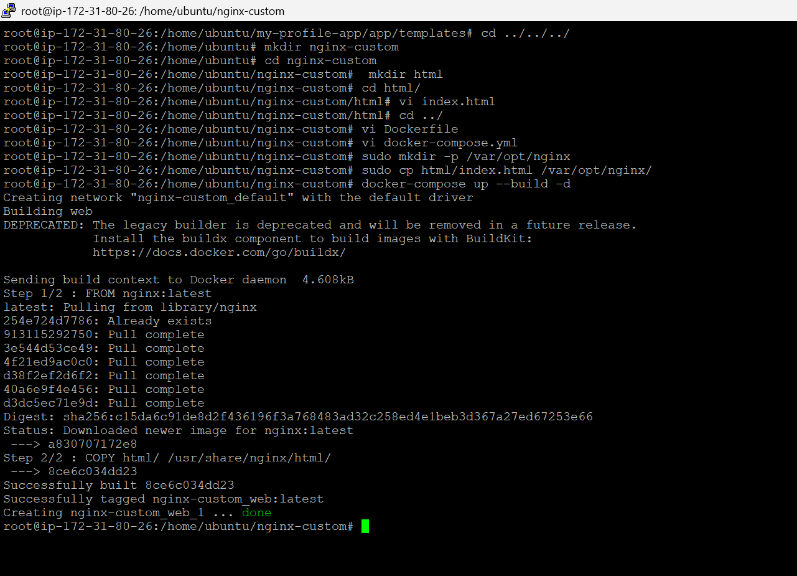
Now visit:
http://3.95.156.36:8080
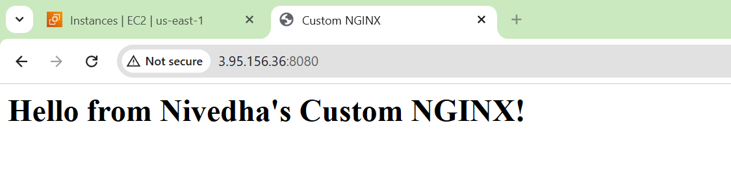

Tag & Push to Docker Hub
docker login
docker images
docker tag 8ce6c034dd23 nivemuthu09/custom-nginx:v1
docker push nivemuthu09/custom-nginx:v1

